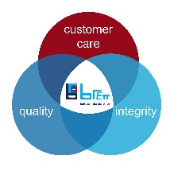


JOB TITLE: | Finance Manager
DEPARTMENT: | Finance
COMPANY: | Brett Aggregates Limited – assigned to Brett Concrete Limited and Capital Concrete Limited
LOCATION: | Aylesford - Brett Concrete Head Office with occasional travel to operational sites.
REPORTS TO: (Job Title of immediate supervisor) | Financial Controller - Concrete
- ORGANISATION: (Show where this job fits in the organisation)

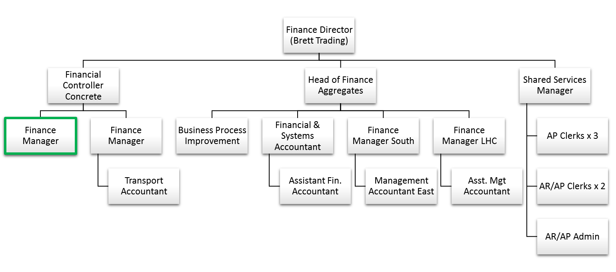

- RESOURCES:
Budget(s) Controlled/Influenced:
- The Concrete finance team provides financial counsel for Brett Concrete and Capital Concrete with 2025 budgeted revenues of circa £45 & £85 million respectively

Number of Direct/Indirect Subordinates: One

Plant/Equipment Responsible For: n/a

Key Internal/External Contacts:
Internal:
- Managing Director(s), Transport Manager(s), Operations Manager(s), Operations supervisor(s), Finance Directors – BTL & RBS, Financial Controller - Concrete, Group & BAL Finance teams

External:
- Auditors, ONS, MPA.
- PURPOSE OF THE JOB:
The purpose of the role is to provide financial counsel to the Concrete businesses and to ensure financial controls are in place and working effectively. The Finance Manager will be the primary contact for the relevant Commercial, Operational and other support teams, providing the following services:

- Preparing and publishing timely accurate monthly management accounts and other key management information.
- Analysing business performance and providing commentary and explanations for variances to budget, forecast and prior year.
- Leading the annual budget and monthly forecast processes, advising and challenging the tactical and strategic assumptions being made.
- Proactively identifying and improving finance and business processes to ensure fast, accurate management information is available.
- Maintaining and improving financial control, including maintaining a clean balance sheet.
- Supporting a successful external audit process.
- Provide cover for Financial Controller on an ad-hoc basis

- MAIN RESPONSIBILITIES/TASKS:

Responsibilities/Tasks:
- Preparation and review of monthly management reports and provision of commentary of business performance against Budget, Forecast and Prior Year on a timely basis, providing insight and challenge to managers to drive improved business results.
- Maintain balance sheet control for all areas of responsibility through up to date balance sheet reconciliations.
- Lead the production, review and analysis of annual budgets and monthly forecasts with all relevant managers.
- Support a successful external audit process.
- Proactively identify and initiate continual improvements in team’s methods of working to minimise cost and improve service.
- Support Financial Controller with other requests / ad-hoc projects

- PERSON SPECIFICATION

Essential:
- Qualified member of ACA / CIMA / ACCA with 4 years minimum management accounts experience, ideally with proven experience in an operational FP&A or finance business partner role.

- Possess strong interpersonal skills, able forge strong working relationships throughout the business and to challenge and influence stakeholders effectively whilst still promoting collaboration and process efficiency.

- Possess strong analysis skills with the ability to interrogate systems, analyse data and produce insightful information which can be used to improve business performance.

- Management Accounting – with a background in product related business, ideally manufacturing, production, distribution or logistics. Demonstrated competence in key management accounting concepts:
- Margin analysis
- Variance analysis and supporting commentary
- Budgeting, forecasting
- Cashflow statement analysis
- Balance sheet control & reconciliations
- GRNI, accruals, prepayments etc, stock accounting and control

- A natural problem solver who is able to see the bigger picture and plan ahead, whilst also being hands on to ensure the timely delivery of the monthly reporting.

- Information Technology – intermediate or advanced Excel skills required (at least pivot tables, lookups, sumif, data validation, graphs and scenario functions). Experience of using integrated business systems / ERP in addition to accounting software.

- Innovation & Change – a proactive and autonomous approach to process improvements with confidence to build process and drive change; continually seeking ways to innovate and improve. End to end business process appreciation.

Desirable
Experience with:
- Working across multiple companies / plants.
- Experience with business partnering multiple stakeholders, including budget holders and operations
- Group reporting structures and intercompany transactions / reconciliations / transfer pricing
- Leading or supporting system upgrades, implementations or major process transformation.
- Capital investment appraisal and post capex review

