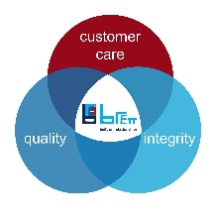


JOB TITLE: | Group Head of Information Services
DEPARTMENT: | Information Services
COMPANY: | Brett Trading
LOCATION: | Canterbury
REPORTS TO: (Job Title of immediate supervisor) | Group Finance Director
- ORGANISATION: (Show where this job fits in the organisation)

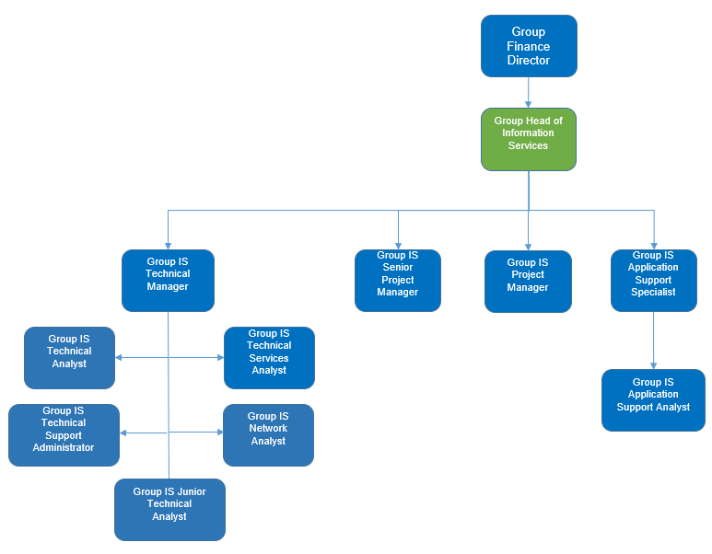

- RESOURCES:

Budget(s) Controlled/Influenced: IS Budget

Number of Direct/Indirect Subordinates: Ten

Plant/Equipment Responsible For: Group-wide software/hardware and Data Centre operations and applications throughout the Group

Key Internal/External Contacts: Group Executive; business leaders and heads of central functions; Group IS team members; 600+ internal users; and key external stakeholders including suppliers, such as ERP and business system providers and help desk service providers.

- PURPOSE OF THE JOB: (What is the main reason for this job to exist? How does it add value to the Company?)

The Group Head of Information Systems is responsible for overseeing the strategic direction, development, and management of the Brett’s information systems and technology infrastructure across all business units. This role ensures that IT operations are aligned with the company’s goals, support business growth and drive digital transformation initiatives. The Group Head of IS will lead the design, implementation, and maintenance of secure, scalable, and efficient systems while managing IT operations, governance, cybersecurity, data strategy, compliance and costs.

- MAIN RESPONSIBILITIES/TASKS: (What will the Job Holder actually do?)

Key Responsibilities:
- Strategic Leadership:
  - Develop and execute a comprehensive IT strategy aligned with the organisation’s overall objectives and translating it into actionable goals
  - Lead digital transformation initiatives and projects to enhance operational efficiency, innovation and help drive growth and profitability
  - Collaborate with senior business leadership to set priorities and identify technological opportunities and challenges and propose ways to resolve them.
- Technology Oversight:
  - Design, implement and manage the full lifecycle of IT systems including infrastructure, applications, networks, and cybersecurity to ensure the most suitable and affordable solutions are proposed and implemented
  - Evaluate and implement new technologies to improve business processes and drive growth
  - Ensure high availability, performance, and security of enterprise IT systems.
  - Staying up to date with emerging technologies and trends to determine their value to Brett
  - Ensure Brett IT users of applications and technology are supported cost-effectively and to the needs of the business

- Governance & Compliance:
  - Establish IT policies, standards, and procedures in line with best practices and regulatory requirements.
  - Lead efforts to ensure compliance with data protection laws (e.g., GDPR).
  - Oversee risk management, disaster recovery planning and assist in business continuity planning
  - Responsibility for day to day management of health, safety and environment as pertaining to the IS department, adhering to Group standards
- Team Leadership & Development:
  - Lead and mentor a team of multidisciplined IT professionals, motivating them and fostering a positive and productive work environment
  - Develop IT talent and foster a culture of innovation, accountability, and continuous improvement.
  - Develop, maintain and manage IT budgets, vendor relationships, and contract negotiations.
  - Work with business leaders and key stakeholders to understand their needs and develop priorities for new initiatives and manage a programme of projects to deliver them.
  - Ability and extensive experience in leading and managing business change related to technology implementations.
  - Guiding, managing and reporting on the day-to-day progress of a large programme of information systems initiatives and projects
Person Specification

Qualifications & Experience:
Essential
- Bachelor’s or Master’s degree in Information Technology, Computer Science, Business Information Systems, or a related field.
- Progressive experience in IT leadership roles, including at least 5 years at a senior/executive level with overall budgetary responsibility, including managing external providers.
- Proven experience in enterprise IT management, systems integration, cybersecurity, and digital transformation.
- Strong knowledge of IT governance frameworks (e.g., ITIL) and compliance standards.
- Experience managing IT operations across multiple sites or business units is highly desirable.
Desirable
- Knowledge of the heavy building materials, logistics and construction industry
- Experience of the IFS ERP system.

Key Skills:
- Strategic thinking and business acumen
- Strong leadership and people management
- Excellent communication and stakeholder engagement
- Project management and vendor negotiation
- Extensive change management experience
- Expertise in enterprise systems (e.g., ERP, CRM, cloud platforms), networks and mobile technologies
- Problem solving and creativity in designing workable solutions for the business, with the IS team and other stakeholders

