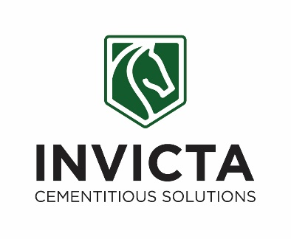

JOB TITLE: | PA/Secretary/Administrator
DEPARTMENT: | Invicta Admin
COMPANY: | Invicta Cementitious Products
LOCATION: | Sheerness
REPORTS TO: (Job Title of immediate supervisor) | Managing Director
- ORGANISATION: (Show where this job fits in the organisation)

- RESOURCES:

Budget(s) Controlled/Influenced: Office spend

Number of Direct/Indirect Subordinates: None

Plant/Equipment Responsible For: None

Key Internal/External Contacts:

Internal – Managing Director, Departmental Managers, On site teams, Members of the Board, Shareholders

External – Customers, external industry contacts and key stakeholders, consultants, meeting room/dining/accommodation contacts and relevant suppliers

- PURPOSE OF THE JOB: (What is the main reason for this job to exist? How does it add value to the Company?)

To provide effective and confidential administrative support to the Director and the wider team, maintenance of company Information Servies systems and main office customer facing support.

- MAIN RESPONSIBILITIES/TASKS: (What will the Job Holder actually do?)

Responsibilities/Tasks:

- Managing incoming & outgoing mail and emails
- Construction of and timely distribution of Board and management meeting minutes
- Telephone calls and dealing with customer enquiries and requirements.
- Diary management for the Director
- Arranging travel & overnight accommodation
- IFS, Command, Employ and QHEST Key Local User
- Efficient running of the office environment.
- Accurate filing and document controls.
- Credit Card reconciliations/expenses
- Document printing, scanning, typing
- Typing correspondence / documents
- Booking and managing meeting rooms
- First point of contact for all visitors

- PERSON SPECIFCATION

Essential:

- Attention to detail with ability to retain knowledge
- Ability to Prioritise with forward thinking
- Clear and concise communication (both written and verbal)
- Excellent telephone manner
- Sufficient literacy and numeracy competency
- Strong multitasking abilities and efficient time management
- Team-oriented with excellent people skills
- Proficient in office software (Microsoft Office, Google Suite, etc.)
- Ability to learn new systems or software quickly and accurately
- Familiarity with front desk equipment (phones, booking systems, etc.)
- High levels of discretion and confidentiality
- Being reliable, adaptable, proactive and able work flexibly

Desirable

- Previous PA/administrative experience in a similar role
- Previous Construction industry knowledge would be beneficial
- A relevant qualification (e.g., Business Administration, Customer Service)
- Knowledge of office protocols and business operations

